Baseline log reg
Baseline L2 test accuracy: 77.71%
Accuracy for class 0: 78.70% Accuracy for class 1: 74.25%
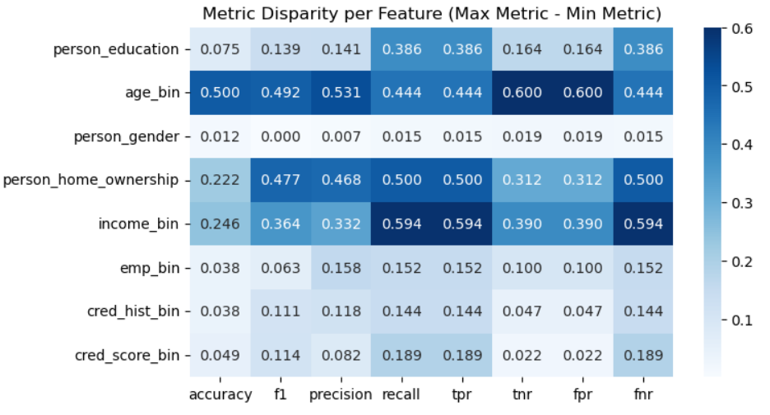
QELM + logistic regression test accuracy: 75.03%
Accuracy for class 0: 73.84% Accuracy for class 1: 79.20%
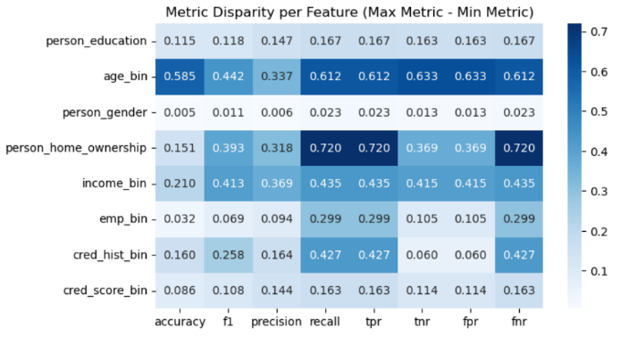

Quantum + PCA test accuracy: 67.51%
Accuracy for class 0: 65.50% Accuracy for class 1: 74.55%
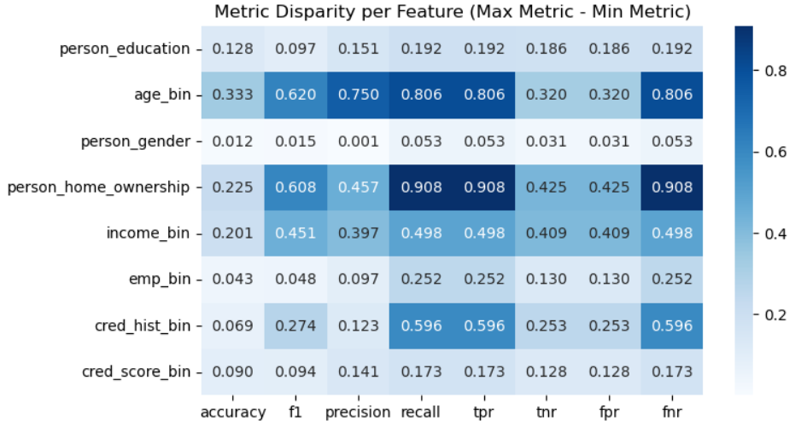

QELM + logistic regression but with age and home ownership removed test accuracy: 69.65%
(lower acc than equivalent log reg but lower bias on age and home ownership)
Accuracy for class 0: 65.07% Accuracy for class 1: 85.70%
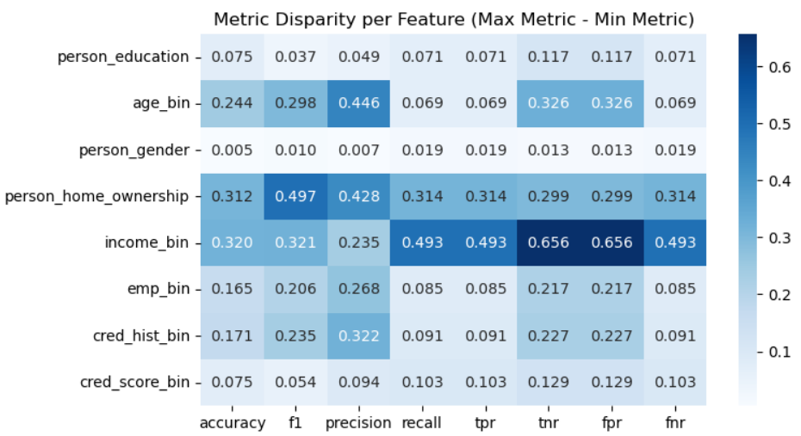
Baseline log reg but with age and home ownership removed: test accuracy: 76.78%
Accuracy for class 0: 77.80% Accuracy for class 1: 73.20%
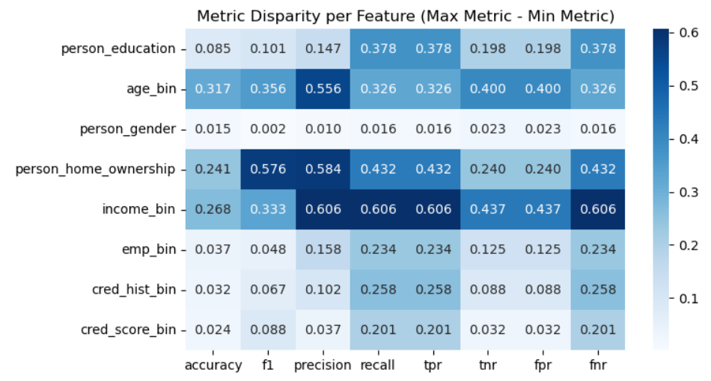

PCA + logistic regression test accuracy: 75.98%
Accuracy for class 0: 76.14% Accuracy for class 1: 75.20%
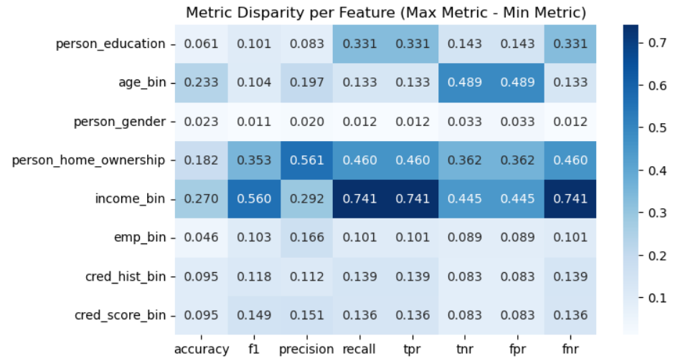
PCA + log reg but with income feature removed before PCA test accuracy: 76.90%
(still bias due to income since other features may be highly correlated with income)
Accuracy for class 0: 77.30% Accuracy for class 1: 75.50%
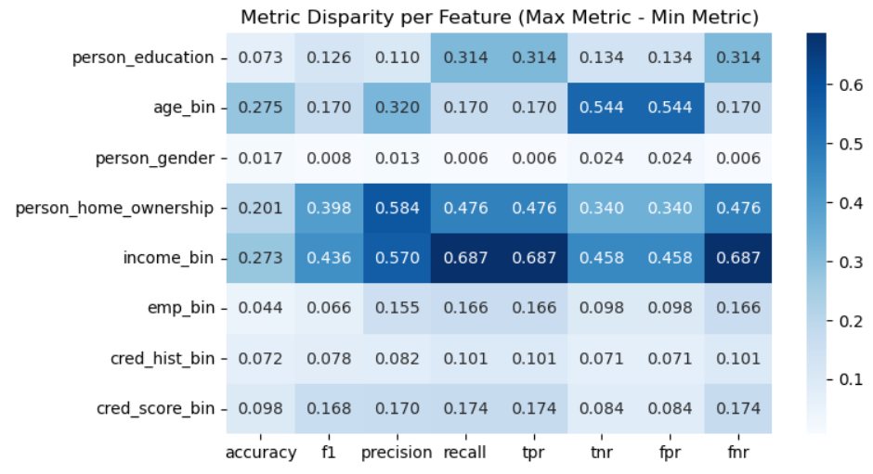
Baseline log reg but with income removed test accuracy: 77.73%
Accuracy for class 0: 78.71% Accuracy for class 1: 74.30%
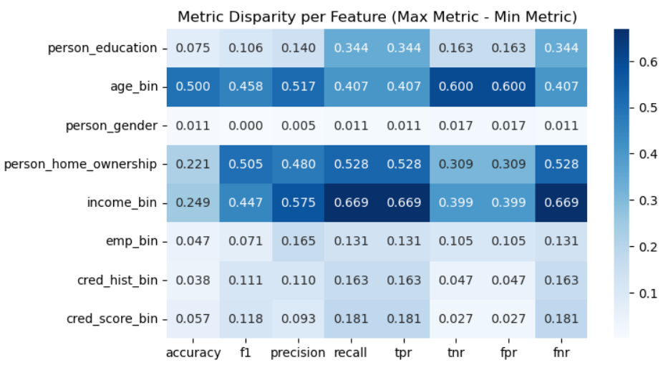

Questions:
1. loan_int_rate??? loan_amt???
2. gender? age?
3. what features do we want to debias?
4. do we want to apply $λ(fairness)$to our modelling to force a change to some bias metric?
5. fairlearn CorrelationRemover you can specify any variable and it removes effects (but only linear effects) of that variable from other variables
6. try QELM/PCA/RFF front end with other models

